Mortgage originations
The amount of mortgage originations can be used as an indicator or consumer availability of credit. The availability of credit is a demand-side variable; as credit becomes more easily available, homeowners’ demand for housing increases.

The Mortgage Bankers Association publishes quarterly mortgage originations data on a national level. The data collected ranges from first quarter 1990 to 4th quarter 2008. The data is for 1-4 family home types and is broken out by purchase and refinance mortgages.

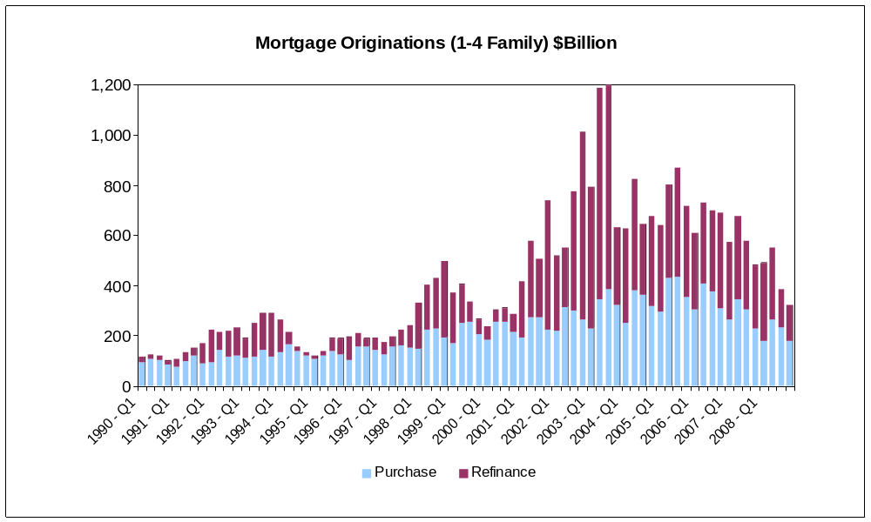

The figure shows that between 1990 and 1994, there was very little refinancing, which is due to high interest rates. Then from 2001 – 2008, every quarter saw a greater amount of refinancing than purchase mortgage financing. The peak for purchase mortgage originations occurred at Q1-2006 while mortgage refinancing peaked in 2003.

More granular mortgage originations data was obtained from Agamas Capital Management. Agamas provided state-level monthly non-agency origination data from September 1996 until January 2008. This data is from ABS Securities Database as provided by Loan Performance, a First American Company.

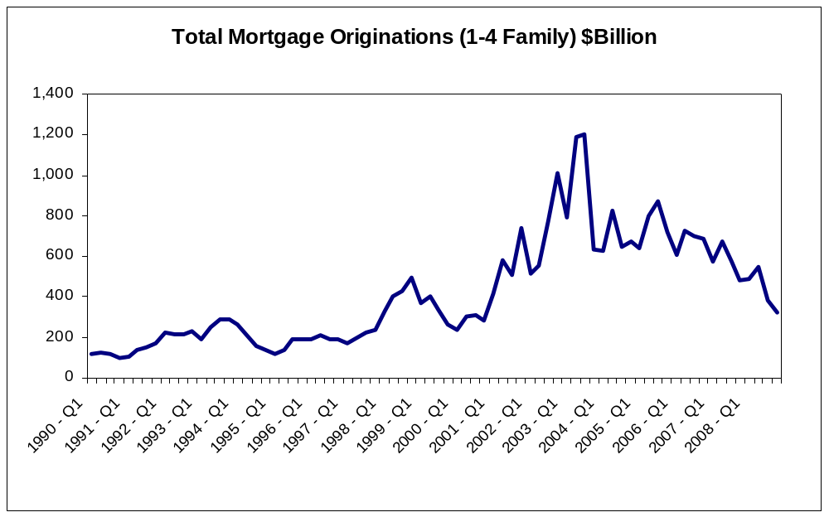

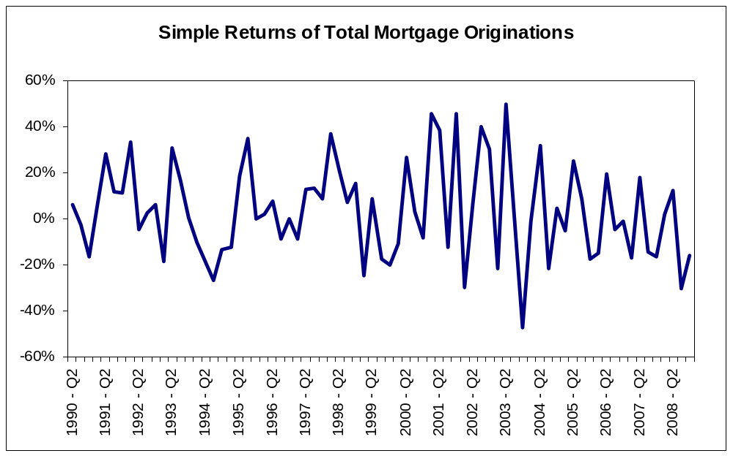

Unemployment Rate

Unemployment can put pressure on the demand for housing. Low unemployment rates indicate a strong and growing economy, which could increase the demand for housing. Conversely, with high unemployment rate, homeowners experience difficulty in making mortgage payments, thus increasing their chances of foreclosure.
Unemployment rates by state were obtained through the Bureau of Labor Statistics. The data is monthly and ranges from 1976 – 2009.

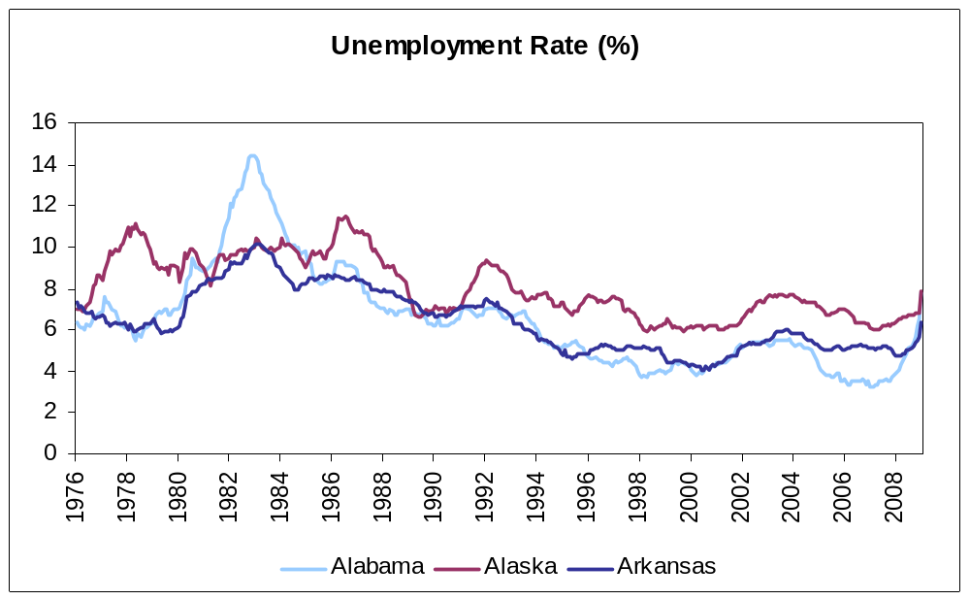

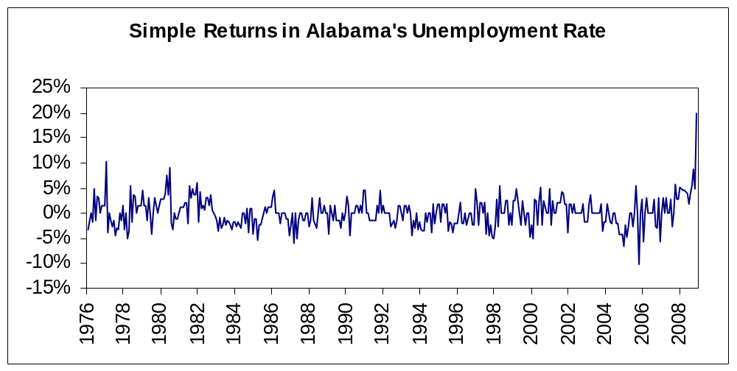

The figure shows that unemployment rate in the period between 1995 and 2007 has been relatively stable and low compared to historical rates, but has seen a steady climb since 2007.

Foreclosures

Housing foreclosures affects the supply of housing. Foreclosed homes increase the total housing supply available and can affect the prices of neighboring houses. State-level monthly non-agency foreclosure data was obtained from Agamas Capital, who uses the ABS Securities Database as provided by Loan Performance, a First American Company.

The date range for the foreclosure data varies for each state, with the earliest beginning in 1997, while other states did not begin until 2000. The last available monthly data is July 2008 for all states.

Median House Price/Median Income Ratio

A measure of housing affordability is the ratio of median house price to median income. A positive trend in this ratio would indicate that homeowners are using a larger proportion of their income to financing their homes.

Median house price and median income data was obtained from the Census Bureau. The data is on a national level on a monthly basis from 1981 to 2008. The ratio was calculated by dividing the median house price by median income for each month.

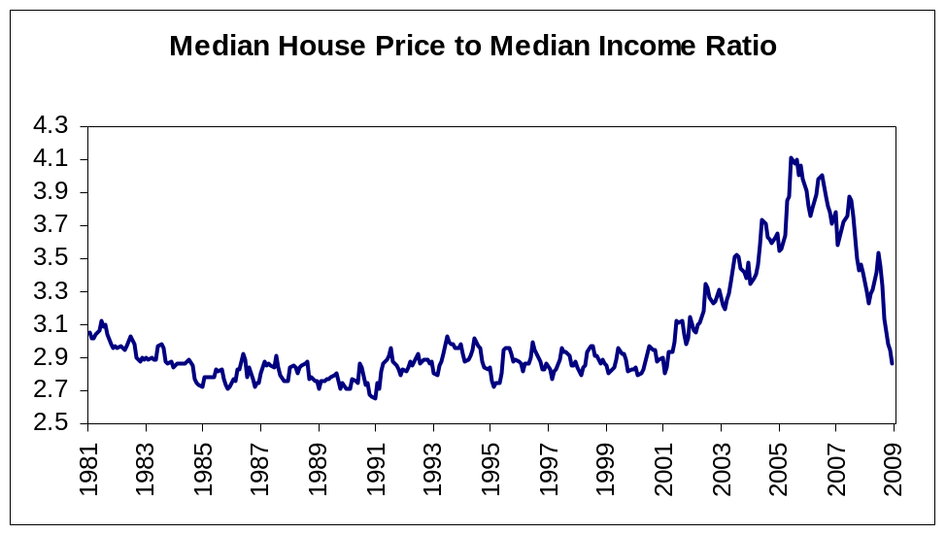

As the figure shows, the ratio increased dramatically starting 2001 and peaked around 2005. This ratio can later be compared to historical averages and a large delta from the historical value would raise concern, signaling that housing is becoming less affordable.
